**Azure Front Door add custom domain & certificate**

We will see how to add a custom domain name and our certificate to the Azure Front Door.

**To add a custom domain name and our certificate we need:**

* The public certificate in PFX format
* Register the Azure Front Door Service Principal
* An Azure Key Vault
* Access to the Public DNS of our custom domain

**Azure Key Vault**

Azure Front Door imports custom certificated only from Azure key Vault. So we need to create a Key Vault and provide access to the Azure Front Door Service Principal.

First register the Azure Front Door Service Principal using this script:

New-AzADServicePrincipal -ApplicationId "ad0e1c7e-6d38-4ba4-9efd-0bc77ba9f037"

(i)Create a key Vault

(ii) At the certificate permissions select the get secret & get & list certificates and authorities

(iii) For principal select the “Microsoft.Azure.Frontdoor” and add.

(iv) at the Network Connectivity method select all networks, or if you select selected networks remember to allow the Azure Front Door Backend IP Range.

(v) go to Certificates -> Generate/Import

(vi) Select Import and upload your certificate.

**Edit the Front Door**

(i)Once the certificate is uploaded successfully, go to the Azure Front Door designer. At the Frontend/domains press the + to add the custom domain.

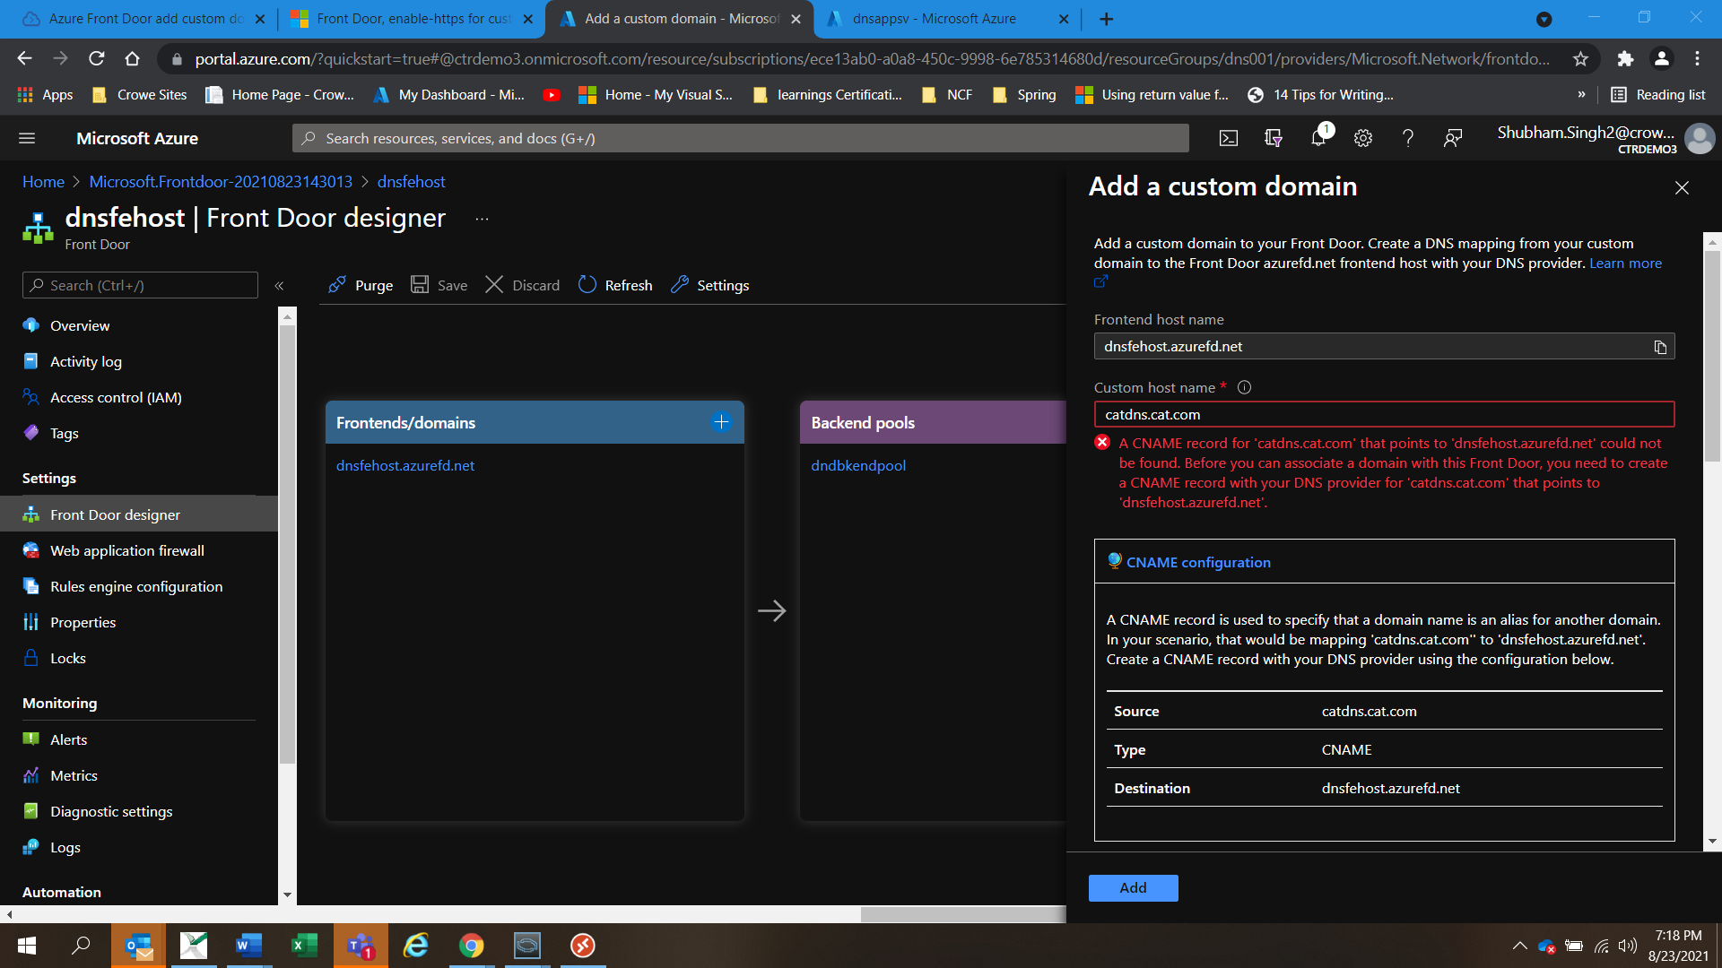

(ii)Write your custom host name and the form will inform you to create a CNAME to point to the front door. We need to do this first to proceed.



(iii)After that enable the Custom Domain HTTPS and select use my own certificate.

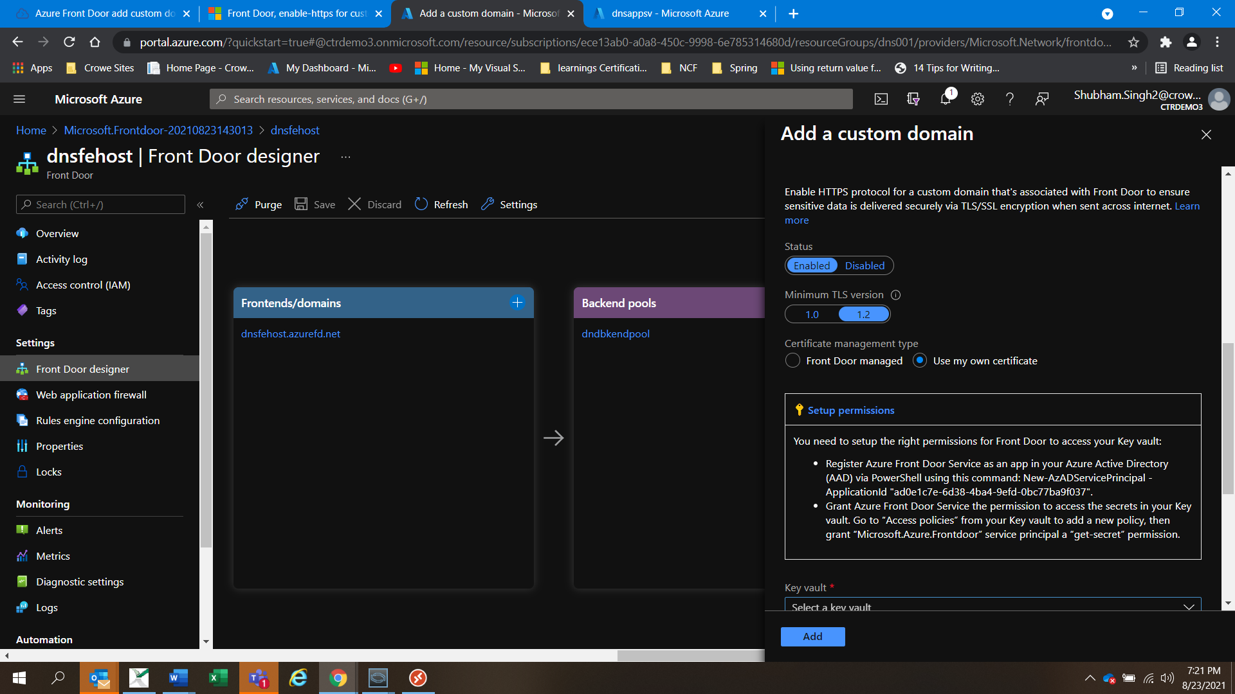

(iv)Select the KeyVault, the certificate and the version and press add and then Save.

(v)The process will start, it will check the certificate and it will import it to the Front Door.

(vi)Now, since we have the SSL termination at the Azure Front Door, we can forward the request unencrypted to our backend, this is called SSL Offload. To do this update routing rule to accept HTTPS only requests, select for frontends the custom domain and for backend forwarding protocol HTTP only.

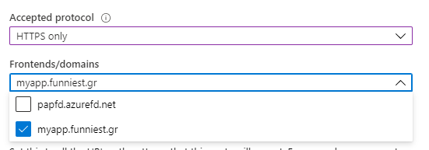

(example figure)

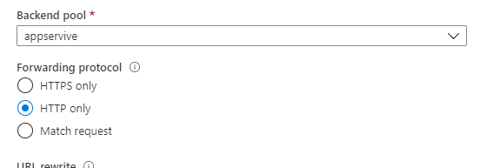

(vii)Then go to the Web App and turn off the HTTPs Only.

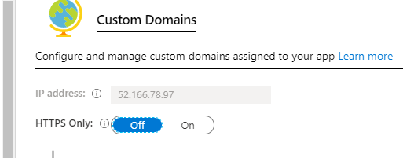

(viii)We can now check our web app at the custom domain.